🧠 Step 1: Problem Framing & Theory Notes
Customer Churn Prediction — Multi-Algorithm Classification Showdown
1. What is Customer Churn? Why is predicting churn valuable for Jio or Airtel?
Customer churn means a customer stops using a company’s service or cancels their subscription. For telecom companies such as Jio or Airtel, churn prediction helps identify customers who are likely to leave so the business can take action before they actually leave.
Churn prediction is valuable because acquiring a new customer requires marketing, sales and onboarding costs. This is Customer Acquisition Cost (CAC). A retained customer can generate revenue over a longer relationship, contributing to Customer Lifetime Value (CLV). Predicting churn early allows the company to target suitable retention actions, reduce customer loss and protect CLV while controlling CAC.
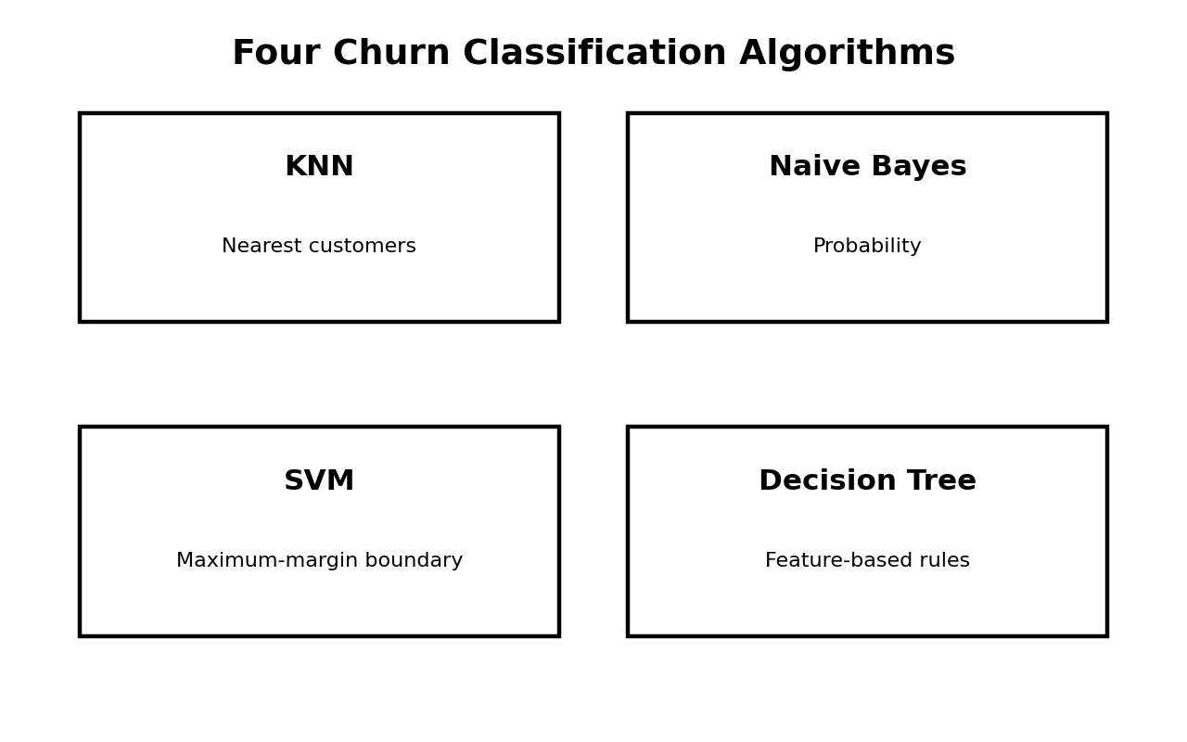
2. Define the four cells of a Confusion Matrix. What is the business cost of FN and FP?
Term | Meaning | Churn Context
TP — True Positive | Actual churn, predicted churn | Correctly identifies a customer likely to leave.
TN — True Negative | Actual stay, predicted stay | Correctly identifies a customer likely to remain.
FP — False Positive | Actual stay, predicted churn | Retention resources may be wasted on a customer who would have stayed.
FN — False Negative | Actual churn, predicted stay | A real churner is missed; future revenue and CLV may be lost.
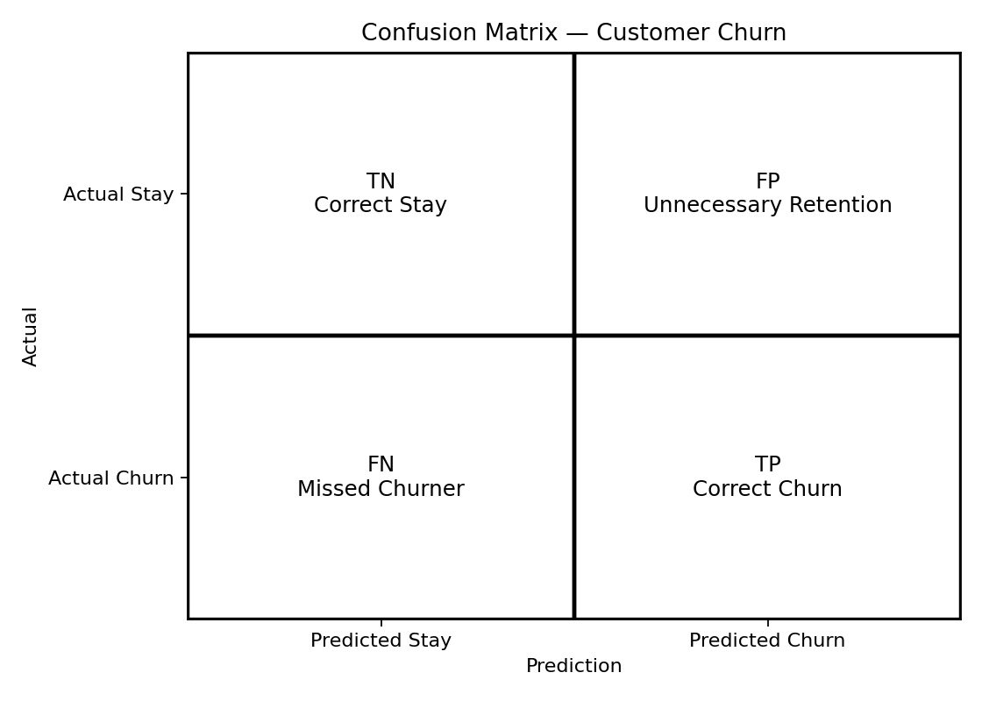
False Negative (FN) is especially costly because the company fails to identify a customer who actually leaves. False Positive (FP) can also be costly because the company may spend discounts, offers or support resources unnecessarily.
3. What is Class Imbalance? Does the Telco Churn dataset have it? How does SMOTE address it?
Class imbalance occurs when one target class contains many more observations than another. The Telco Customer Churn dataset is imbalanced because No-Churn customers are more numerous than Churn customers.
SMOTE (Synthetic Minority Over-sampling Technique) creates new synthetic minority-class observations using existing minority samples and their nearest neighbours. This gives the model more examples of the minority class. SMOTE should be applied only to the training data, never to the test data.
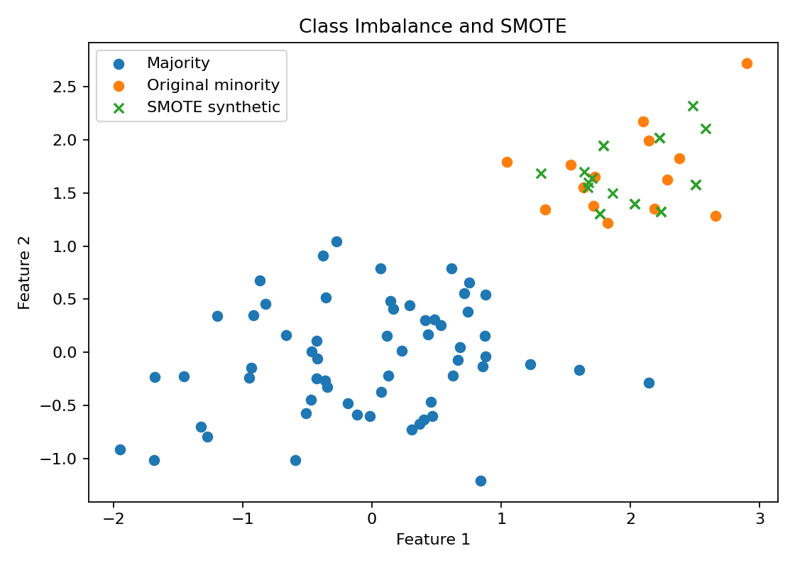
4. Briefly explain KNN, Naive Bayes, SVM and Decision Tree.
Algorithm | 2–3 line explanation
KNN | K-Nearest Neighbours predicts a new customer using the K most similar customers in the training data. The majority class among those neighbours becomes the prediction.
Naive Bayes | Naive Bayes uses Bayes’ theorem to calculate the probability of each class. It assumes features are conditionally independent given the class, making it simple and fast.
SVM | Support Vector Machine finds a decision boundary that separates classes while maximizing the margin. With an RBF kernel, it can model non-linear churn patterns.
Decision Tree | A Decision Tree repeatedly splits customers using feature-based rules. The sequence of splits forms an interpretable tree that leads to a final churn or stay prediction.
5. When would you choose Precision over Recall as your primary metric?
Precision should be preferred when False Positives are more costly than False Negatives. In churn prediction, suppose a telecom company gives expensive discounts or special retention benefits to customers predicted to churn. If the model produces many False Positives, the company wastes its retention budget on customers who were actually going to stay.
Therefore, when the retention team has a limited budget and wants to contact only high-confidence churn-risk customers, Precision can be the primary metric. If the main objective is to catch as many real churners as possible, Recall is more important.
⭐ Quick Viva / Exam Summary
• Churn = customer leaves the service.
• CAC = Customer Acquisition Cost; CLV = Customer Lifetime Value.
• FN = real churner missed; this can cause lost future revenue.
• FP = unnecessary retention action and wasted resources.
• Telco Churn has class imbalance because No-Churn is the majority class.
• SMOTE creates synthetic minority samples and is applied only to training data.
• KNN = neighbours; Naive Bayes = probability; SVM = margin; Decision Tree = rules/splits.
• Recall is important when missing churners is costly; Precision is important when unnecessary retention actions are costly.

